***Read Me File : The Little Cake Co. Cake Blogging website.***

This is the home page of the website, the first page you see when you open the website. 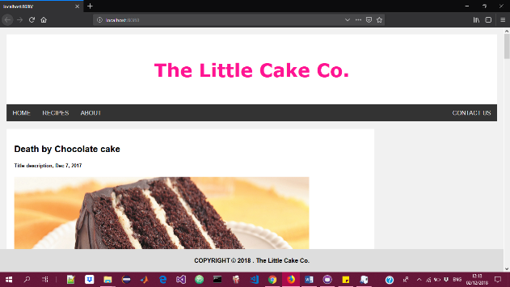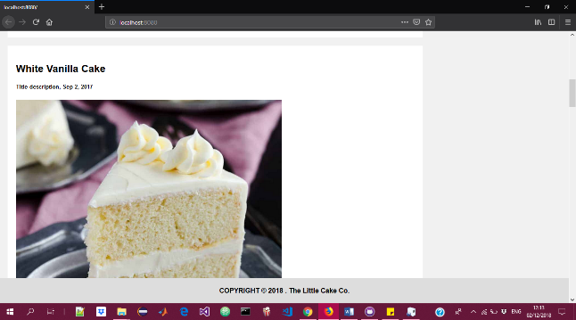

In the home page, we have the ‘HOME’, ‘RECIPES’ , ‘ABOUT’, ‘CONTACT US’ in the top navigation. After the top navigation bar, we have a series of blog posts, articles with their dates posted.

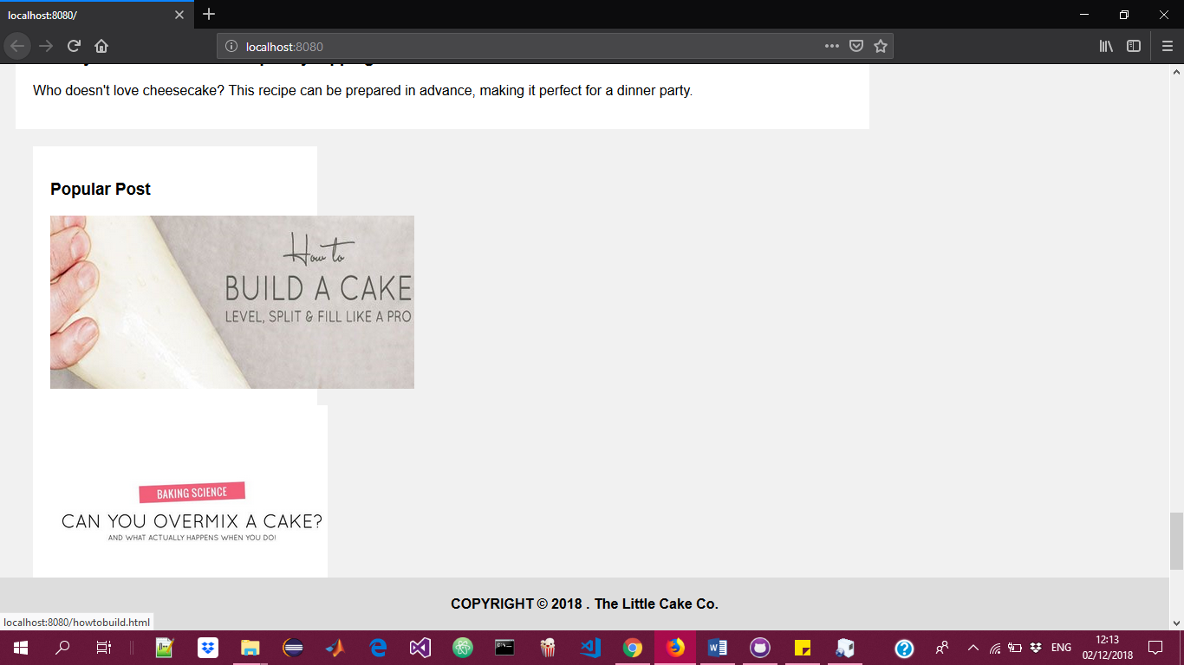

Below the posts, we have the ‘POPULAR POSTS’ card which is a series of the most popular posts, here, there is a collection of images which are links to popular posts from a differet blog.

For example, the first image links to this page.

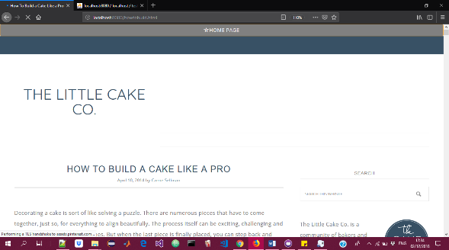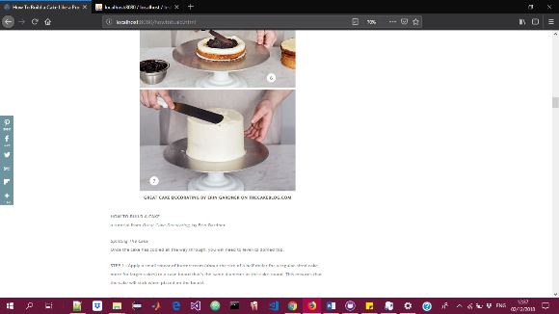

Under the ‘POPULAR POSTS’ card, we have the follow me area which contains links of other social media accounts

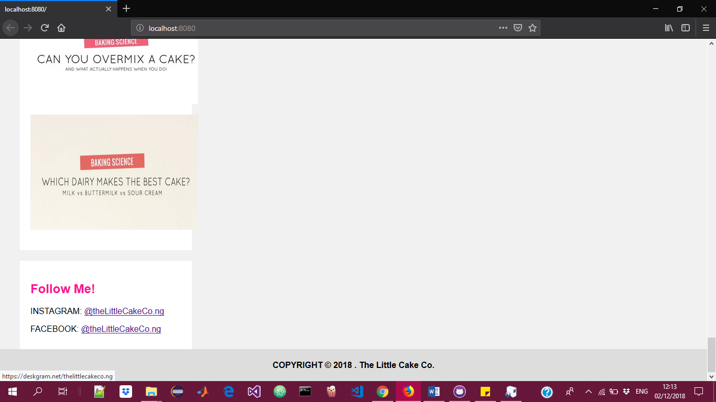

The first link takes us to the instagram account, where clients can see more work and follow. 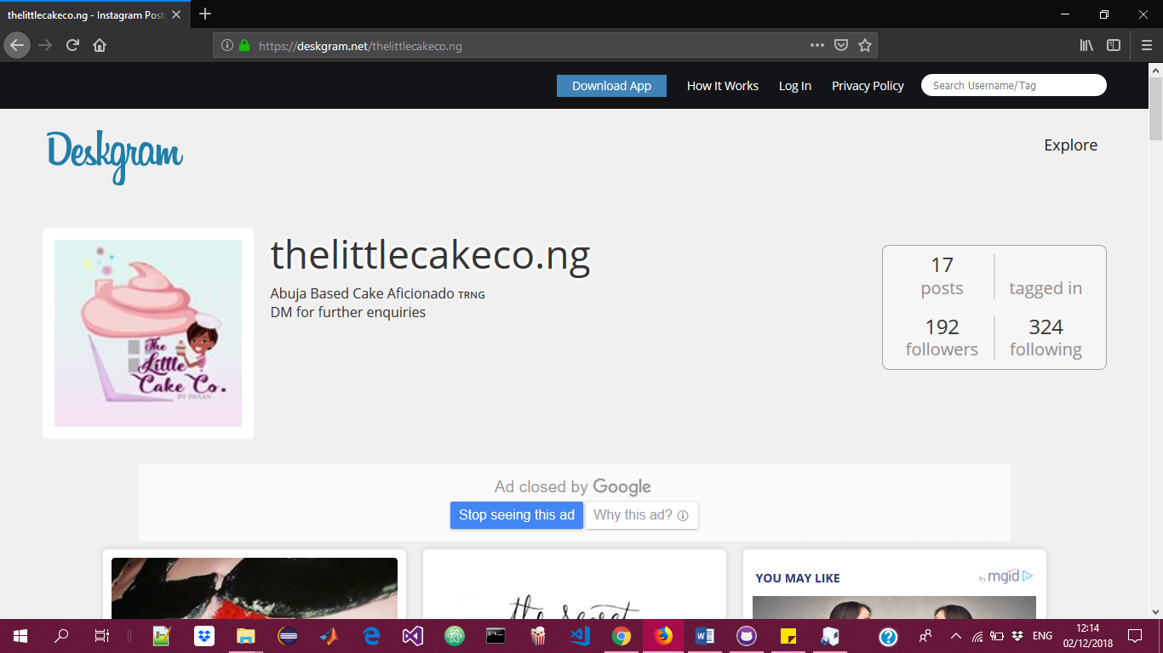

Back in the home page, the first link ‘HOME’ links to the same page. The second link ‘RECIPES’ links to the recipes page.

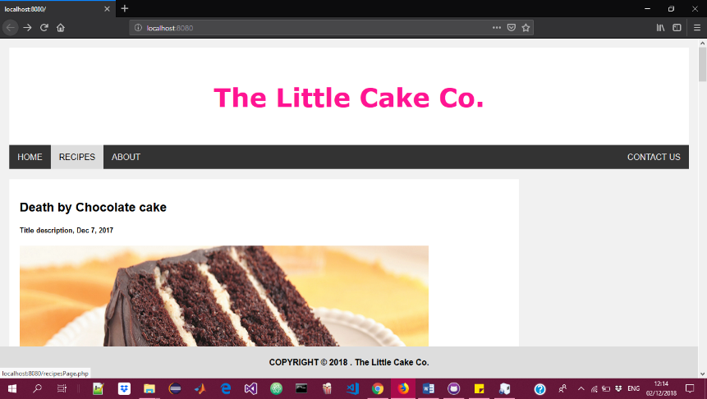

In the Recipes page, you have 3 parts. The first part is the ‘SEARCH A RECIPE’ part, where you can type any keyword and search for it in the recipes database. The second part accesses ‘ALL RECIPES’ in the database and the third part ‘ADD A RECIPE’ allows the user to add a certain recipe into the database.

***Recipe Page***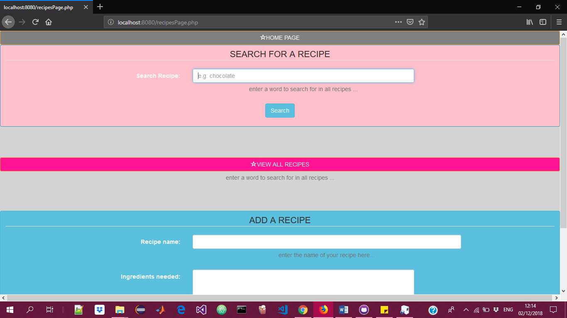

***Let us search for ‘ch’***

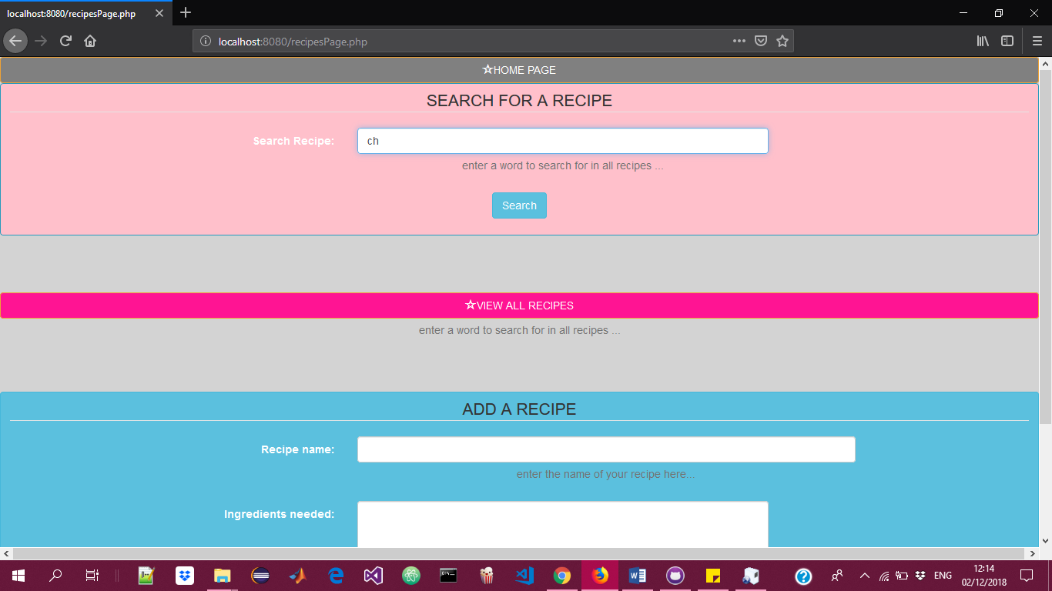

***All recipes with ‘ch’***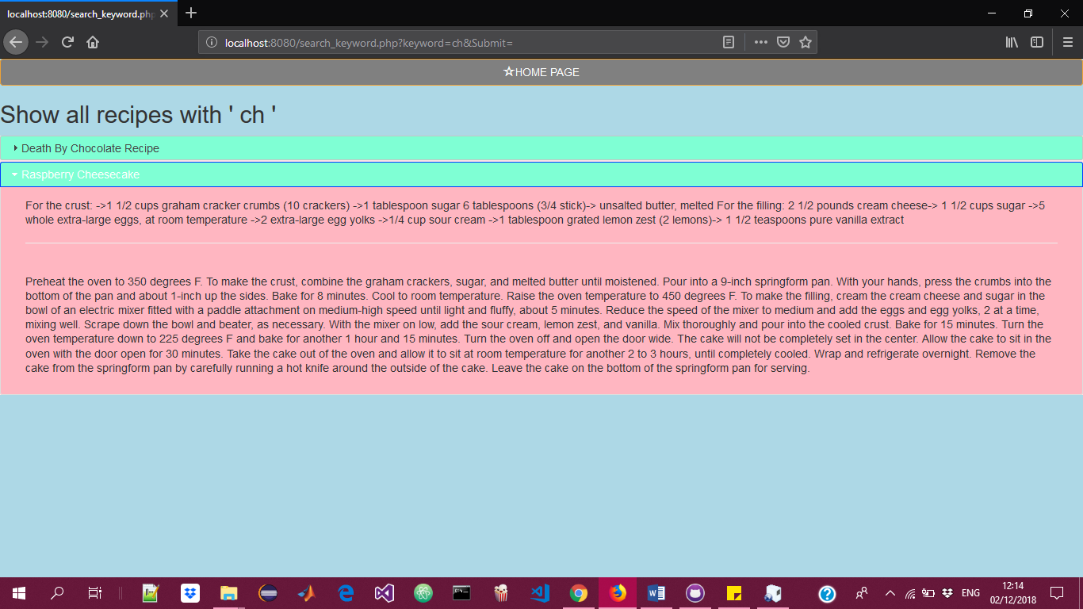

***Back to recipes page clicking ‘VIEW ALL RECIPES’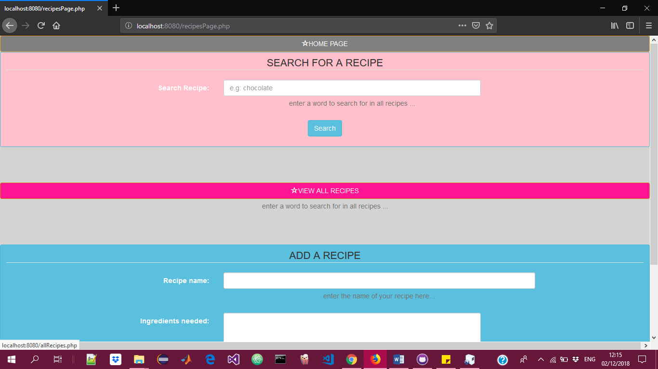results of the ‘VIEW ALL RECIPES’ displays all recipes.*** 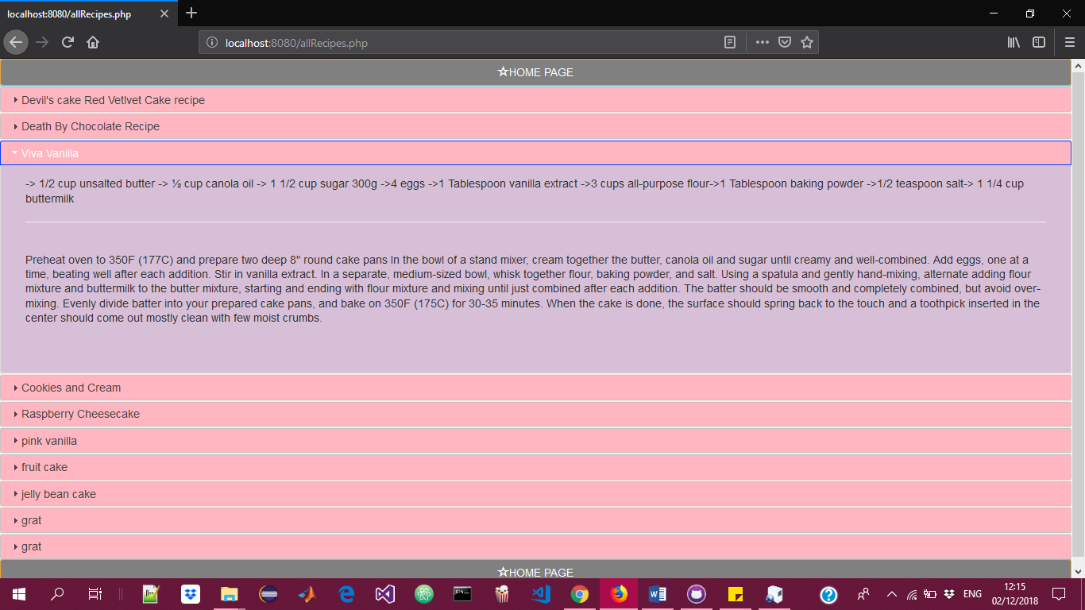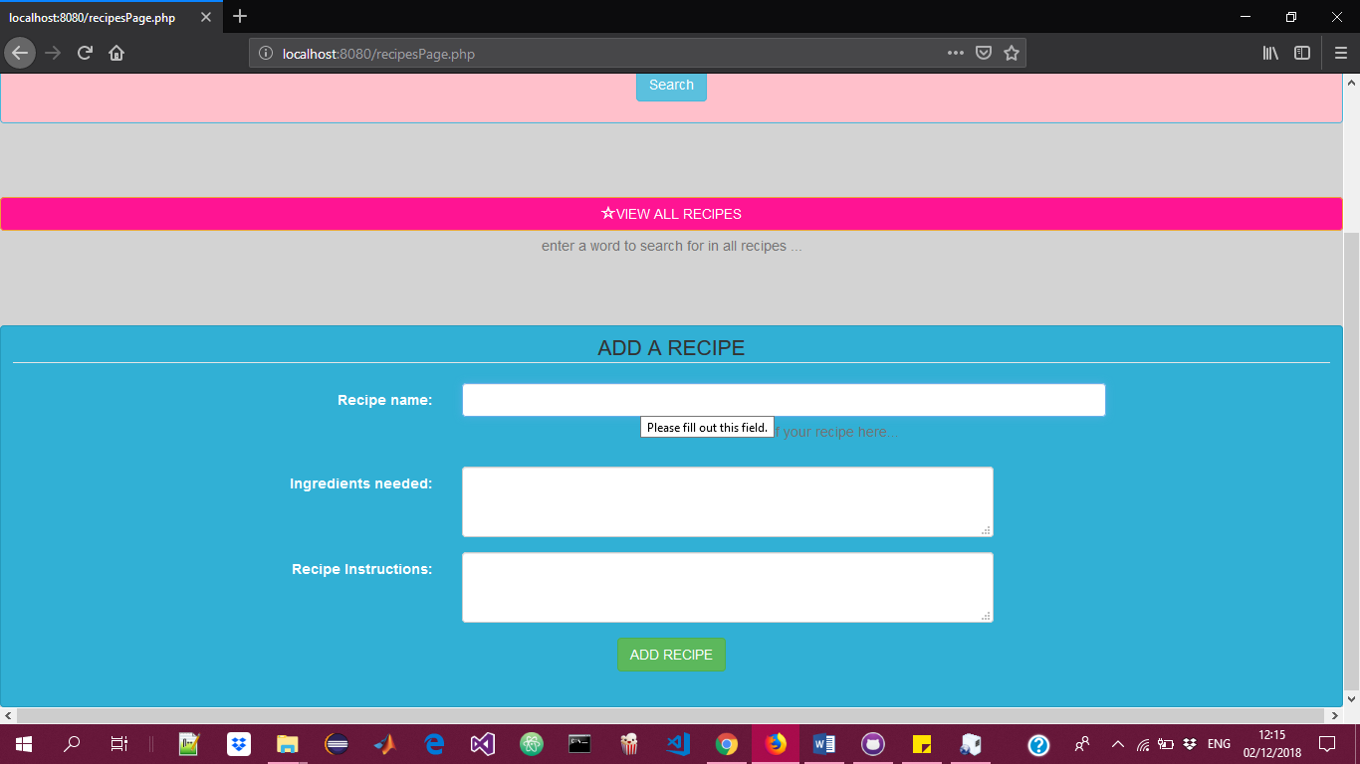

***‘ADD A RECIPE***

***Adding a recipe***

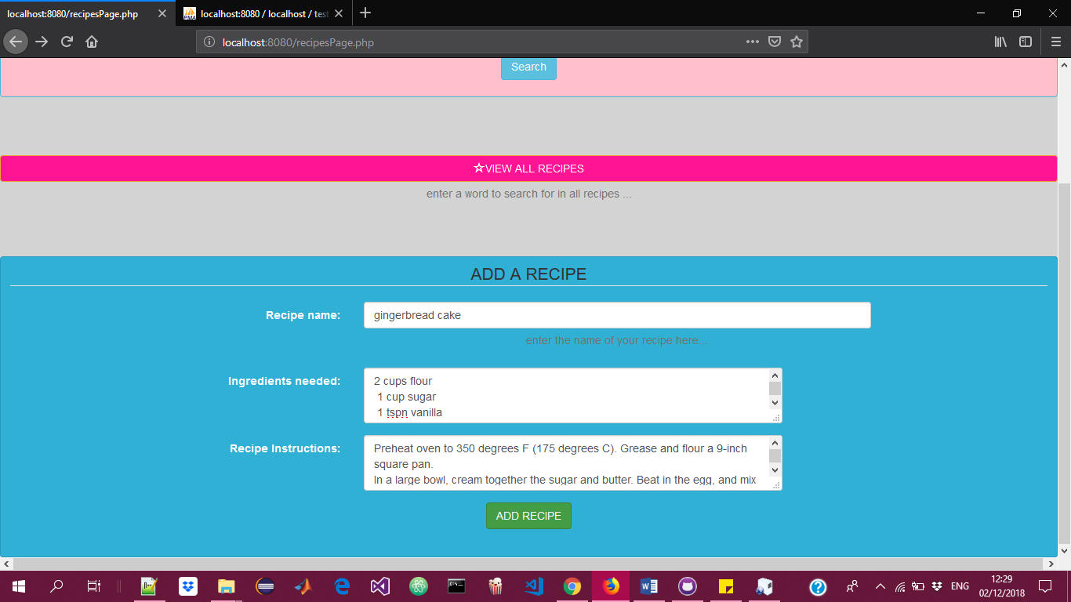

***Recipe Added***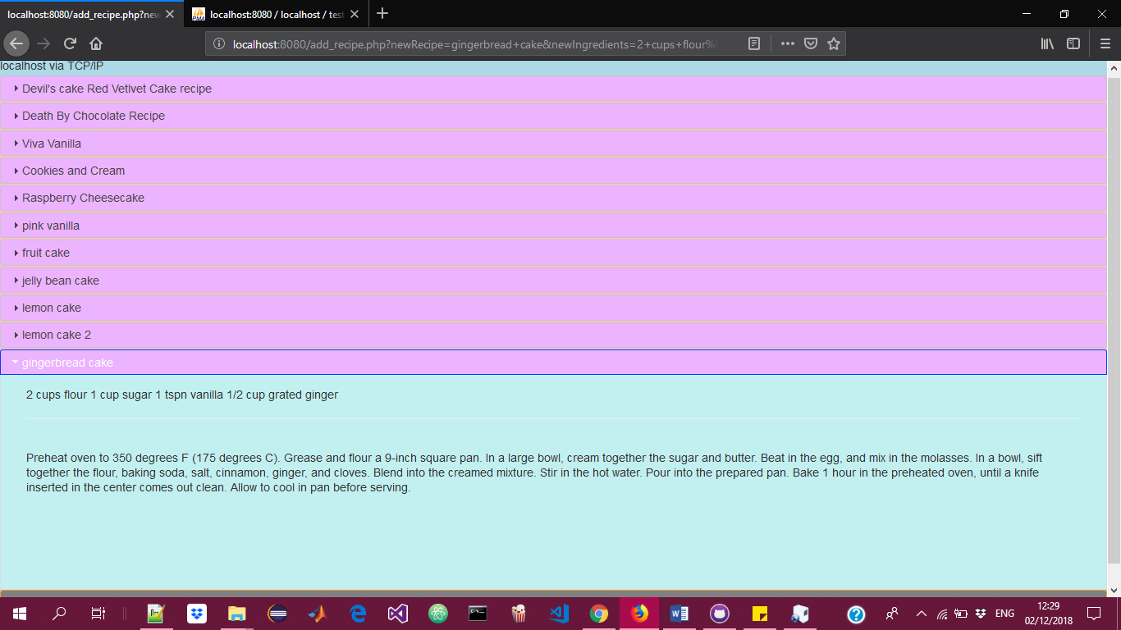

***‘ABOUT’ link in the top navigation bar links us to a page that tells the user about the author and aout The Little Cake Co.***

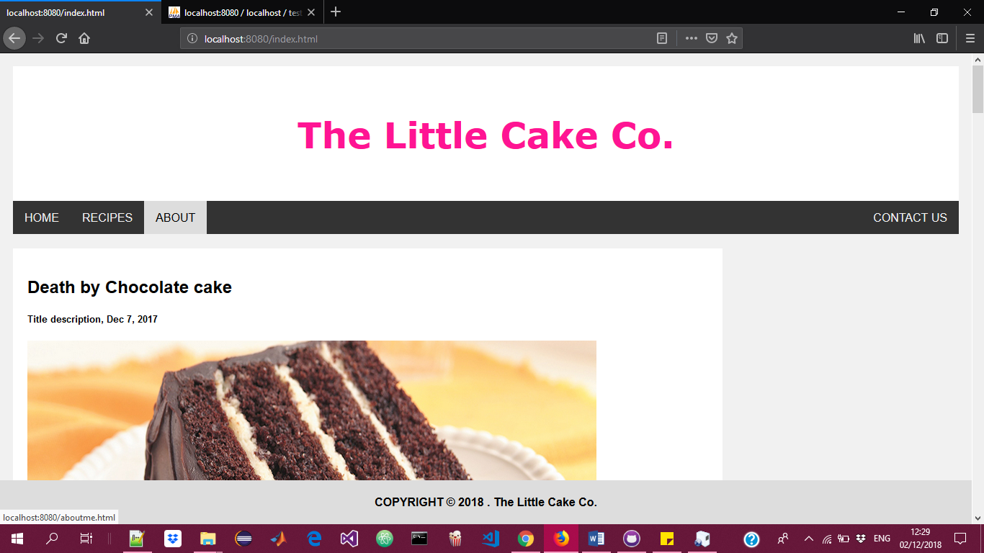

***About page describing the company and the author. The logo links back to the home page.***

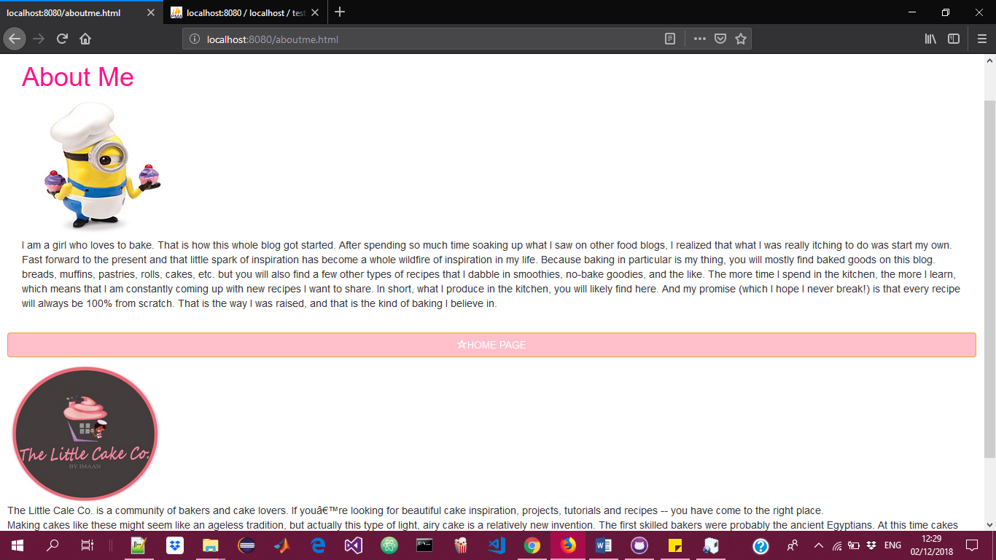

***‘CONTACT US’ page links to the page where the user can contact the author***

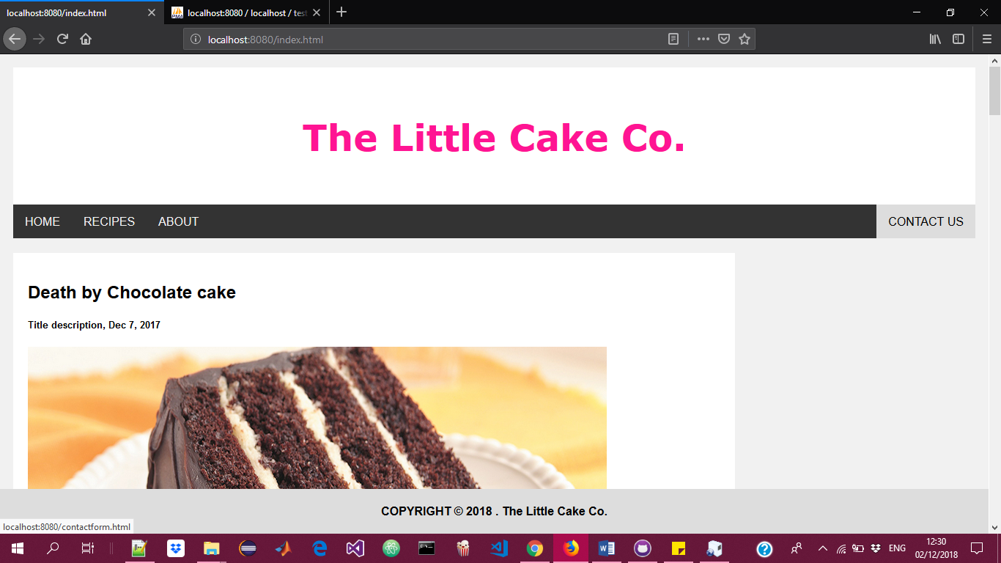

***The contact us page contains a form to be filled. And this comment is sent directly to the author’s email address***

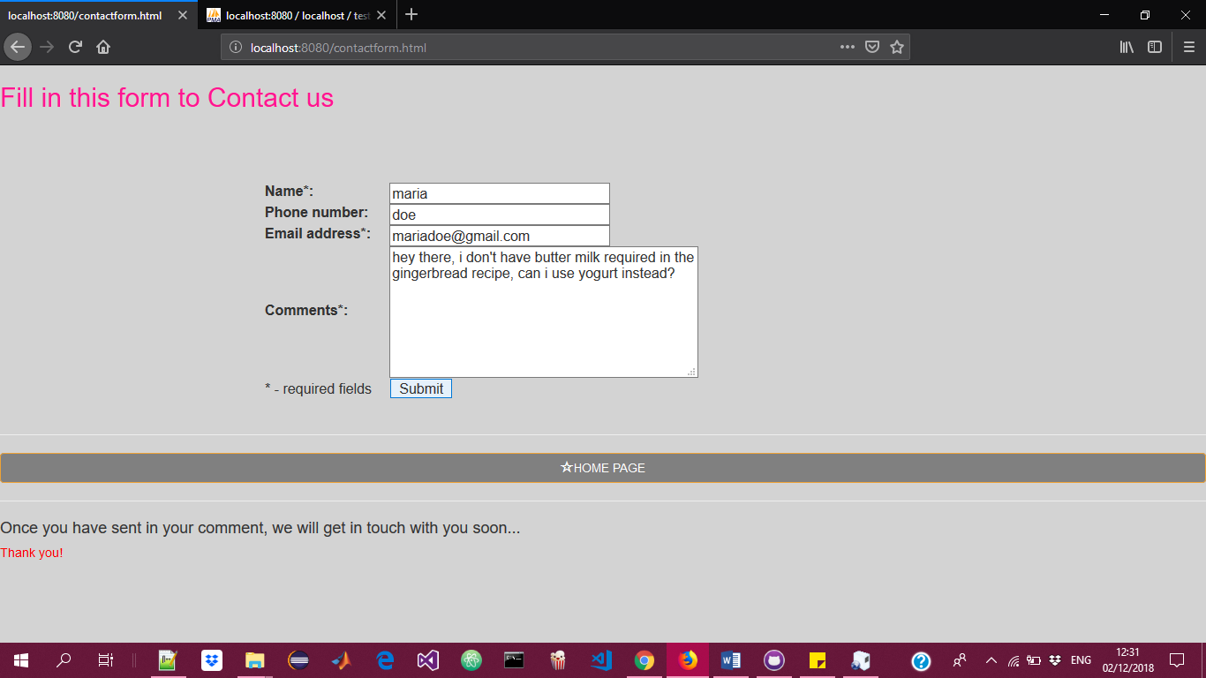

***This is the form being sent to the author’s email address..***

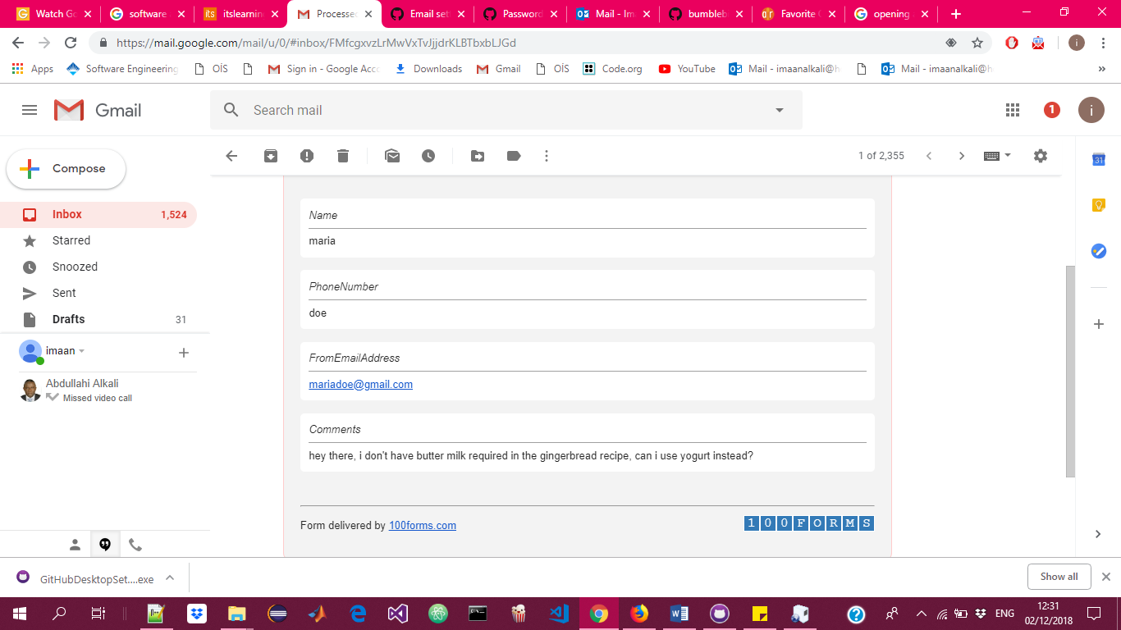

***The senders email address is highlighted for an easy reply from the author.***

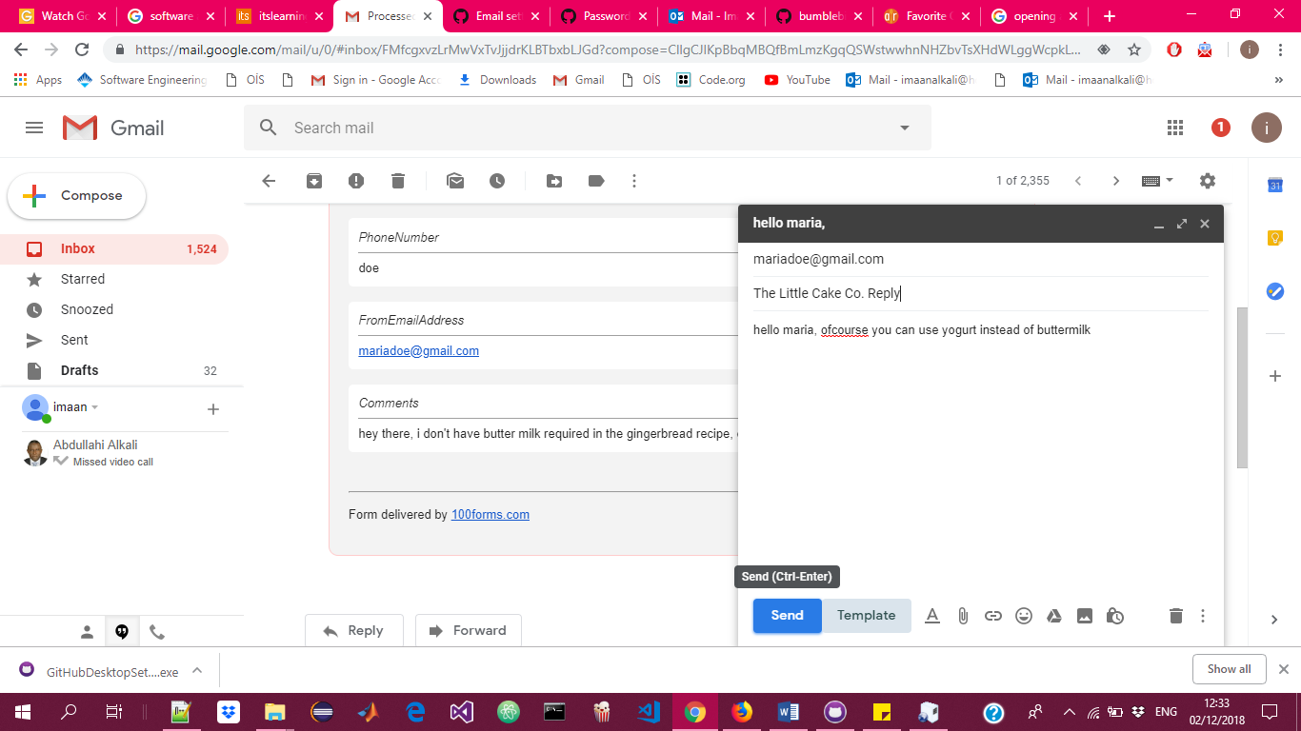

***The website is also responsive to size.***

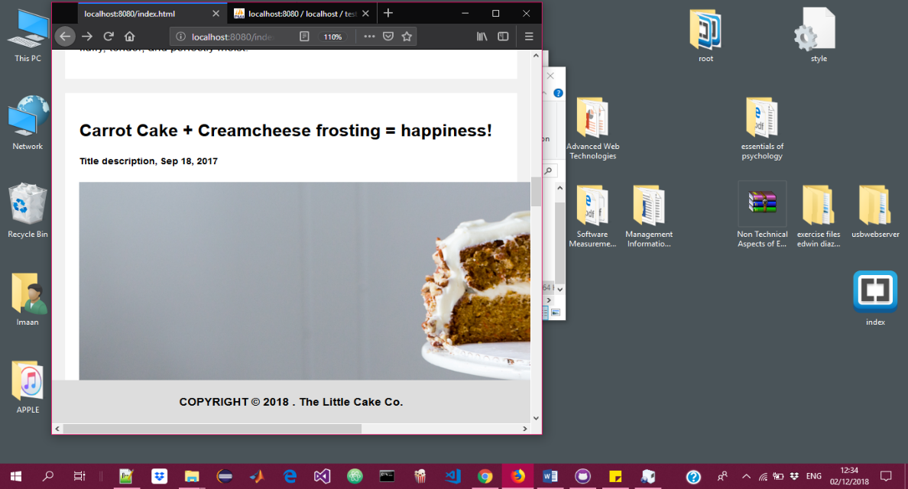

***Showing the responsiveness of the website***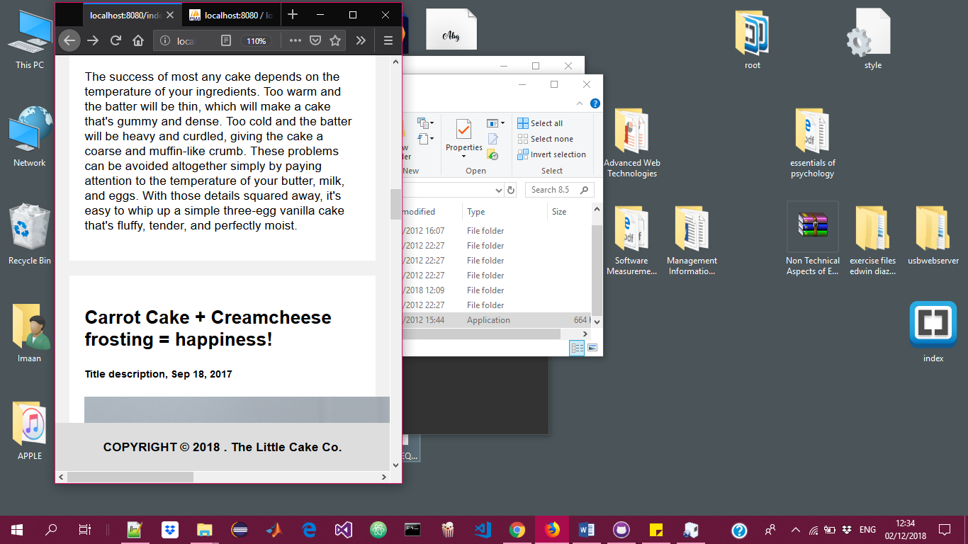

***See how the text and contents of the page changes according to size.***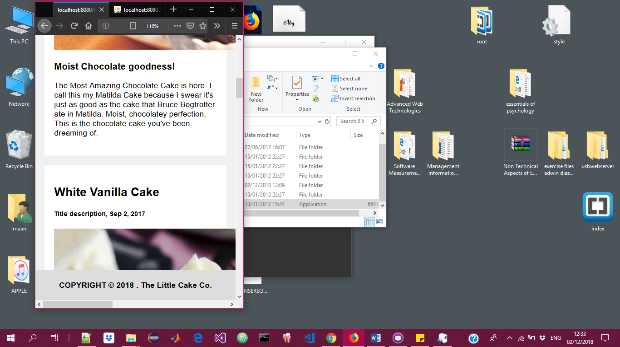

***Finally, my database. This is the database containing the recipes searched and added.***

